PRE-TICKET AMENDMENTS

SPLIT BOOKINGS - This function would be used if you want the passenger to have their own reference, if one passenger from the booking wanted to amend or if one passengers wanted
to cancel.
To split a passenger, you select the passenger you would like to split by ticking the
box next to the name as below:
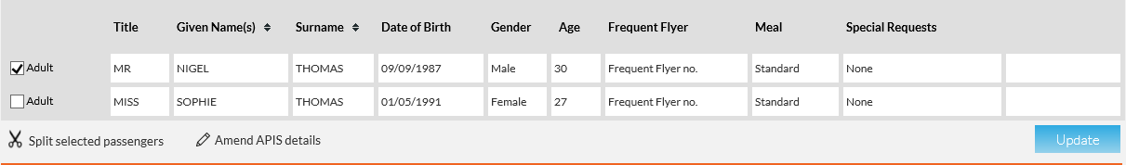
You will then need to select ‘split selected passengers’ also highlighted above.
You will then see a confirmation pop up box where you need to click confirm and this will then split the passenger on to their own reference.
HINT – The bookings will still be linked by the PNR drop down box in the right-hand corner of both bookings.

AMEND SELECTED FLIGHTS – This function is the main function you will use for pre-ticket amendments. This would be used for if the passenger would like to upgrade, change their dates, amend their route to amend their flight times.
Firstly, you will need to select the flights that you would like to amend, you do this by ticking the box next to the flights as below:
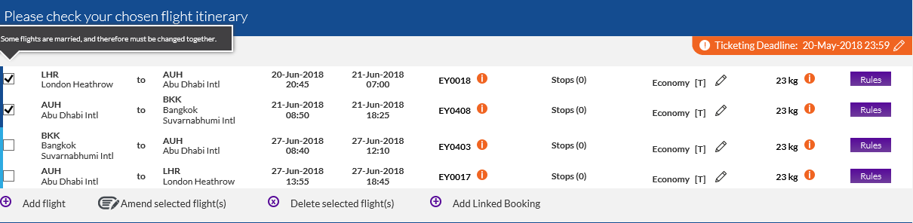
You will then need to select ‘Amend selected flights’ also highlighted above.

The website will then bring up the below box:
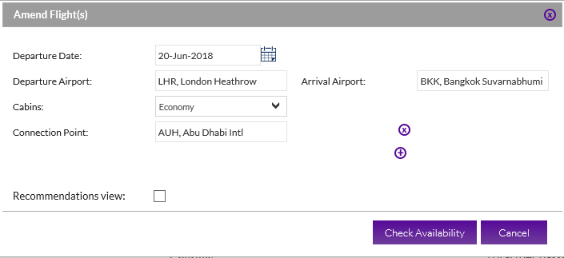
You will need to amend the details in within here to what the passengers want to
change to. Once the information in here is correct you can choose ‘Check Availability’ highlighted above.
The next page will then be your availability page to show you the different options that you can choose for your amended flight. Once the flights have been selected click review and continue to take you to the summary page.

The summary page will give you a breakdown of the new costs, itinerary and the new ticket deadline. You can also read the new fare rules from here too, as highlighted below:
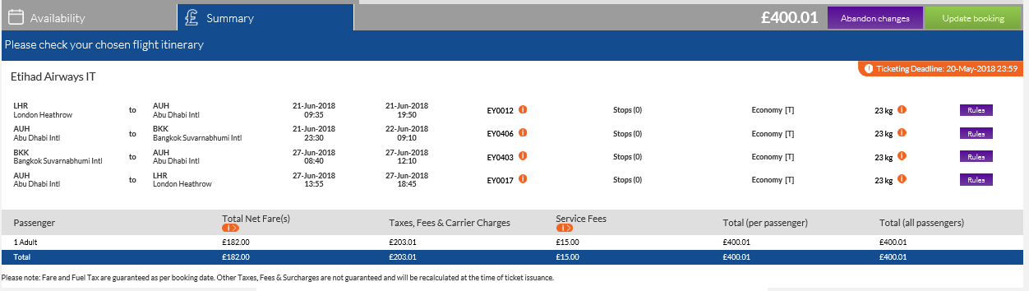
If you would not like to continue with the amendment then click abandon changes.
This will then take you back into the booking and no amendments will be made.
If you would like to continue with the amendment then click Update booking. The website will then process the necessary amendments and take you back into the booking which will now show the amended details.

Add Flight – This function would be used if your passengers would like to add any flights
to their booking.
To add a flight to the booking you will need to select the ‘Add flight’ button as
highlighted below:
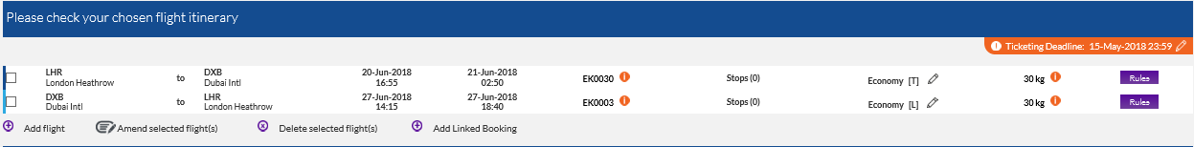
You will then see the below box:
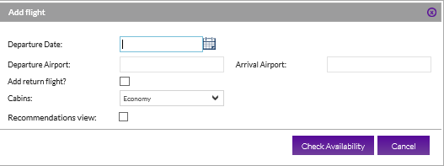
You will need to fill out the above information and then choose check availability.

Delete Selected Flights – This function would be used if you want to remove a certain sector out of an itinerary.
To delete a sector from an itinerary you will need to select which sector you would like to delete by ticking the box next to the sector as highlighted below:
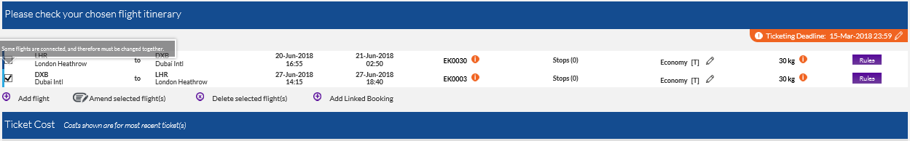
You will the need to select ‘Delete selected flights’ highlighted above.
This will then take you straight to the summary page with a breakdown of the new costs, itinerary and the new ticket deadline. You can also read the new fare rules from here too.
If you would not like to continue with the amendment then click abandon changes. This will then take you back into the booking and no amendments will be made.
If you would like to continue with the amendment then click Update booking. The website will then process the necessary amendments and take you back into the booking which will now show the amended details.

